**­­Climate Change Indicators Analysis**

In conducting this analysis, a total of 16 countries were carefully chosen to ensure representation from diverse continents and regions. The selection includes a mix of advanced economies and emerging ones, aiming for consistency in comparison where feasible.

Various indicators have been chosen to examine the economic status, energy and fuel consumption, and land topography of the selected countries. The World Bank datasets cover the period from 1960 to 2022; nevertheless, for several metrics and countries, data values for the early years are unavailable. In such instances, suitable starting years have been designated to ensure a comprehensive analysis.

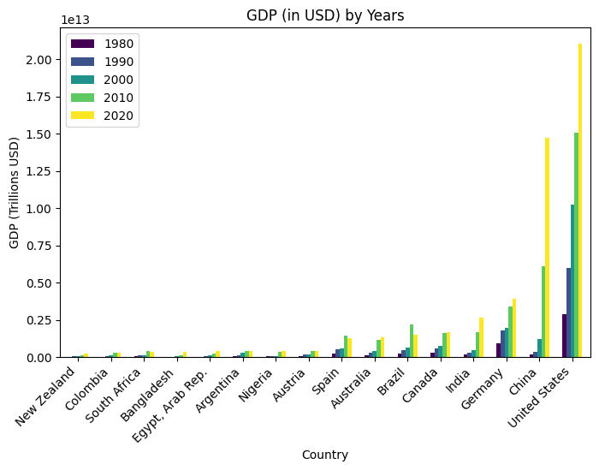

The above graph shows GDP of each country over a decade, spanning values from 1990 to 2020. Out of all these countries, United Stats and China seem to have been placed on top for their exponential growth in their GDP

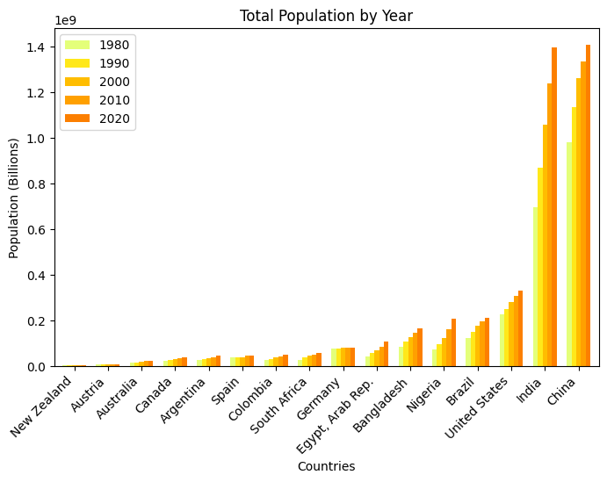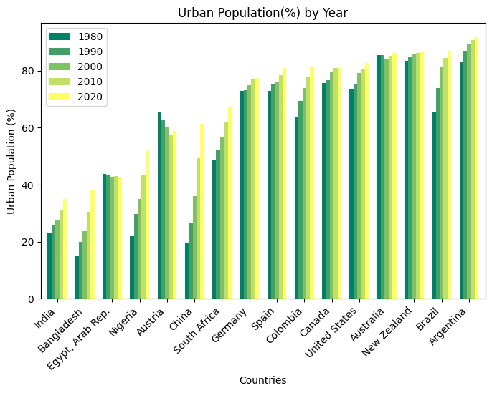

By observing these graphs, one can see that country with higher increasing population showed a significant rise in GDP as compare to other countries. Rise in urban population has shown economic growth, opening wide range of economic opportunities as compared to rural regions. India, though having 4th position in GDP per growth but it has shown a huge spike in GDP from 2010 – 2020, indicating the utilization of human capital.

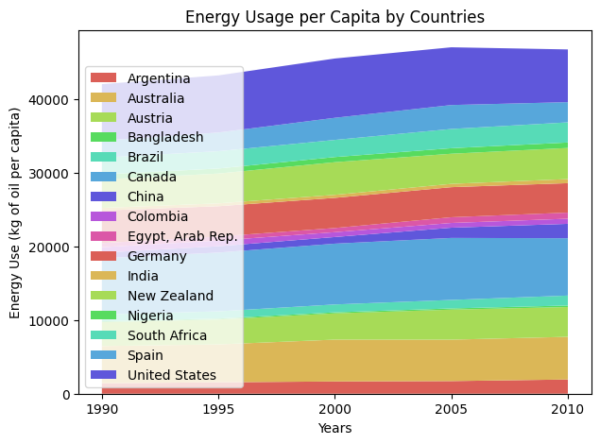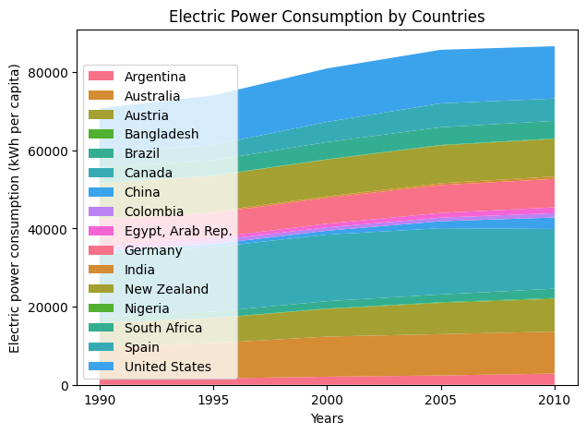

A rise in resources usage shows increase in energy consumption globally. One of the big reason for this is rise in urban population over the years. Major powerhouses are consuming huge amount of power for higher economic prosperity

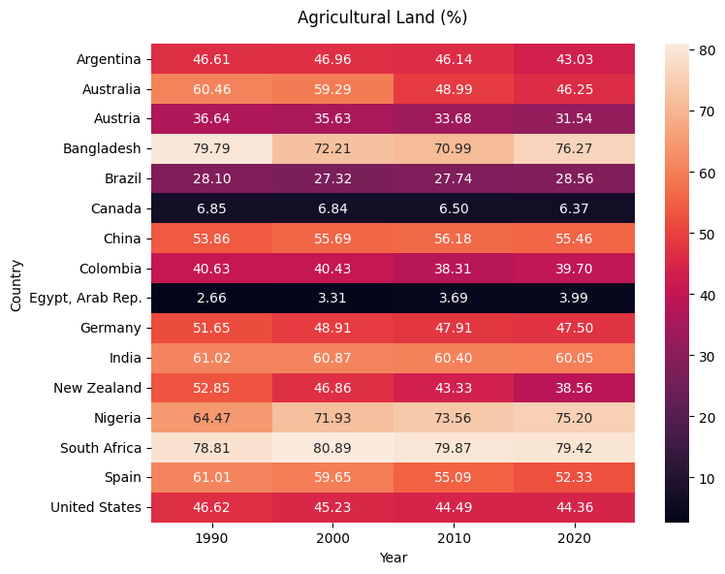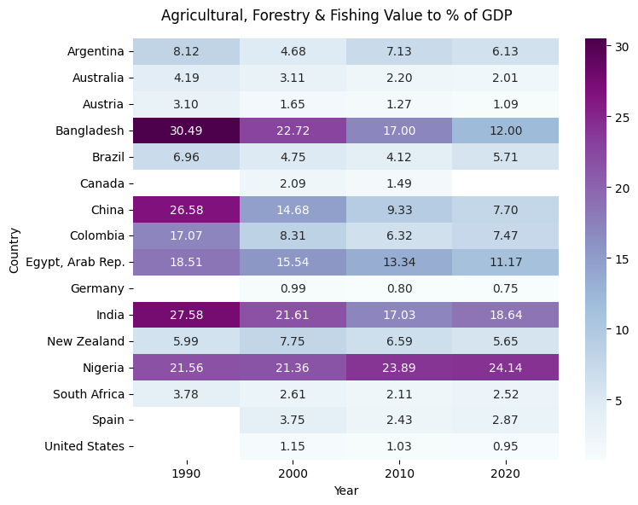

Agriculture plays a significant role in country’s GDP, contributing to the overall economic development. We can see drop in ratio of agricultural for countries throughout the year which reflects the value added by agriculture to the GDP also dropped by a significant percentage. However, countries like India & China, which maintained the ratio of agricultural land showed significant increase in GDP

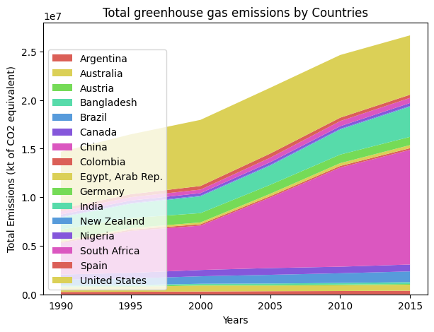

The graph on left shows exponential growth in greenhouse gas emissions in atmosphere. Activities, such as increase in burning of fossil fuel and deforestation, have significantly increased the amount of greenhouse gas in the atmosphere